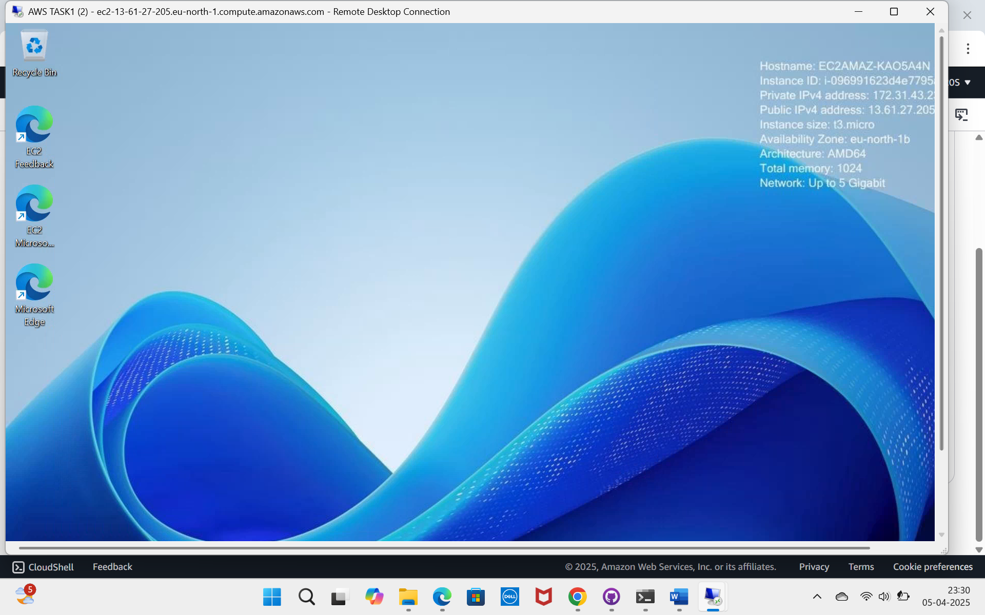

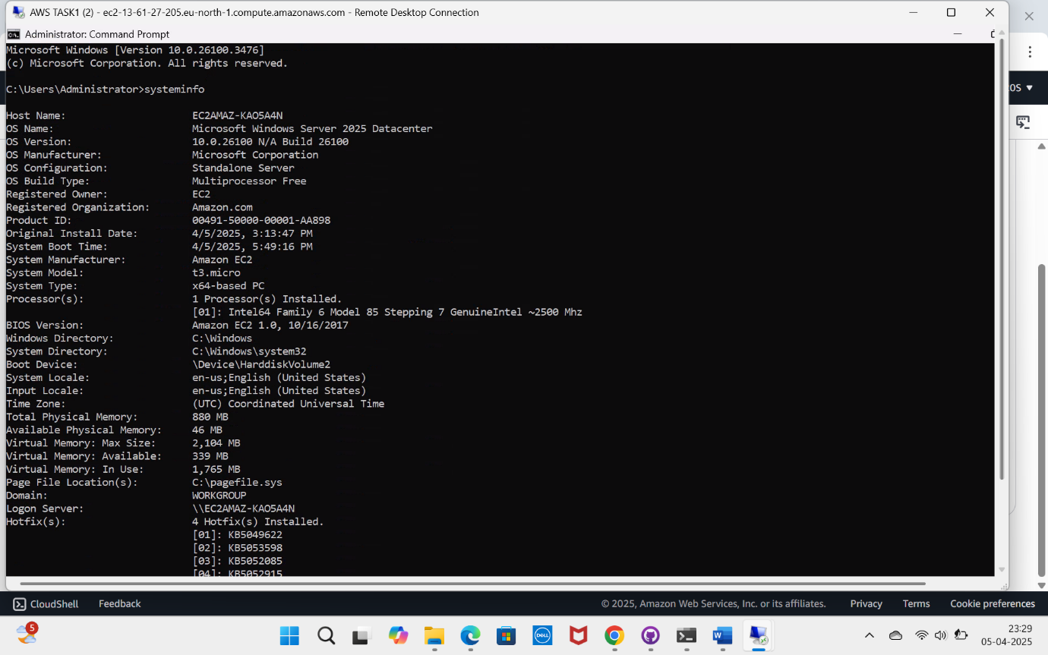

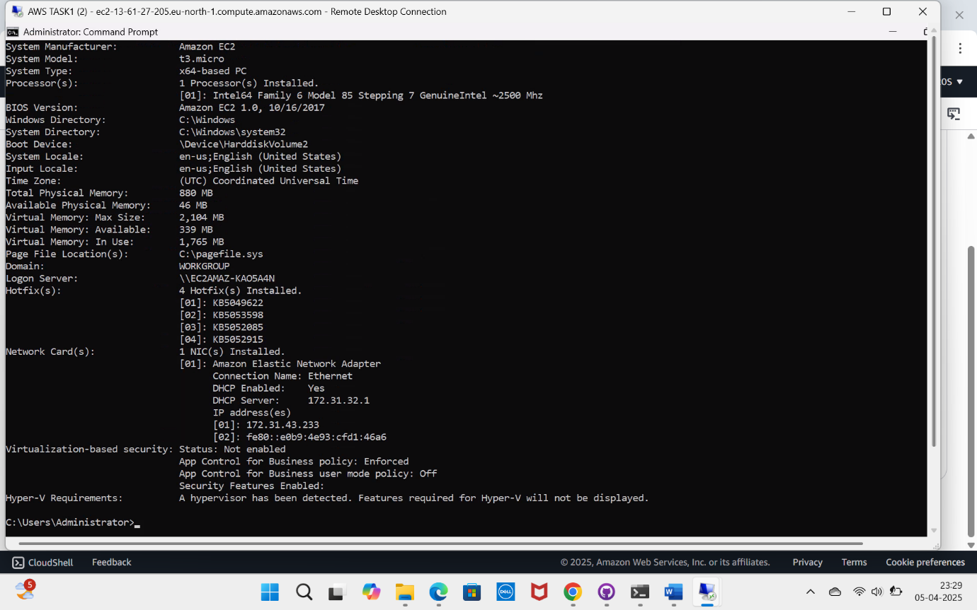

STEPS:

1. LOGIN TO THE AWS ACCOUNT.
2. EC2 ->INSTANCES ->LAUNCH NEW INSTANCE.
3. GIVE A NAME ->SELECT WINDOWS OS ->INSTANCE TYPE -> CREATE A NEW KEY PAIR.
4. CHOOSE RDP PORT OPTION IN SECURITY GROUP.
5. LAUNCH INSTANCE.
6. OPEN RDP APP IN LOCAL WINDOWS MACHINE.
7. GIVE DOMAIN NAME , USER NAME, AND PASSWORD.
8. AFTER LOGIN GO CMD AND TYPE SYSTEMINFO TO VIEW SYSTEM INFORMATION.